Lab 3

Part 1
The 2 tables, Artist and CD, presented below will be used throughout this exercise

SELECT * FROM Artist;
artID | artName
6 | Animal Collective
3 | Deadmau5
7 | Kings of Leon
4 | Mark Ronson
5 | Mark Ronson & The Business Intl
8 | Maroon 5
2 | Mr Scruff
1 | Muse

SELECT * FROM CD;
cdID | artID | cdTitle | cdPrice | cdGenre | cdNumTracks
1 | 1 | Black Holes and Revelations | 9.99 | Rock | NULL
2 | 1 | The Resistance | 11.99 | Rock | NULL
3 | 2 | Ninja Tuna | 9.99 | Electronica | NULL
4 | 3 | For Lack of a Better Name | 9.99 | Electro House | NULL
5 | 4 | Version | 12.99 | Pop | NULL
6 | 5 | Record Collection | 11.99 | Alternative Rock | NULL
7 | 6 | Merriweather Post Pavilion | 12.99 | Electronica | NULL
8 | 7 | 7 Only By The Night | 9.99 | Rock | NULL
9 | 7 | Come Around Sundown | 12.99 | Rock | NULL
10 | 8 | Hands All Over | 11.99 | Pop | NULL

Tasks:
- Write the SQL necessary to represent the tables and data presented above. Notes,
  - You are not required to perform any additional table/data design.
  - Your output for the queries
    - SELECT * FROM Artist;
    - SELECT * FROM CD;
  - Should match that presented above.
  - You are required to provide sensible data types, attributes and constraints for each column.
  - The exact constraints and data types have not been and will not be specified here. Rather you should assess the data as presented and use your judgement to determine these properties according to your real world knowledge and design experience.

- Write the SQL necessary to answer these queries:
  - List the titles and prices of CDs in order of price from highest to lowest.
  - List the Artist Name, Titles and the Price of CDs in alphabetical order by artist name. The Price of the CD should be returned in a column called ‘Full Price’ with tax (20%) included - the CD price in the database is not inclusive of tax.
  - List the titles, genres and prices CDs in alphabetical order by genre, then by price from the highest price to the lowest one.

- Write the SQL necessary to answer these queries:
  - Find the lowest price of any CD. The result should be presented in a column named ‘Cheapest CD’
  - Identify the difference between the most expensive and cheapest CD. The result should be presented in a column named ‘CD Price Range’.
  - Find the number of CDs costing 9.99. The result should be presented in a column named ‘Count of £9.99 CD’s’
  - Find the title of the most expensive Electronica CD(s).
  - Find the number of different Prices in the CD table.
  - List all the information about the cheapest (lowest priced) CDs.

Part 2 - Homework

- Please complete this part by hand
- This isn’t an assignment and is thus not marked.
- Finish it and bring your questions to the lab in the next week.

Task 1: Inner Join, Natural Join
Given tables “books” and “authors_of_books” shown below:

books
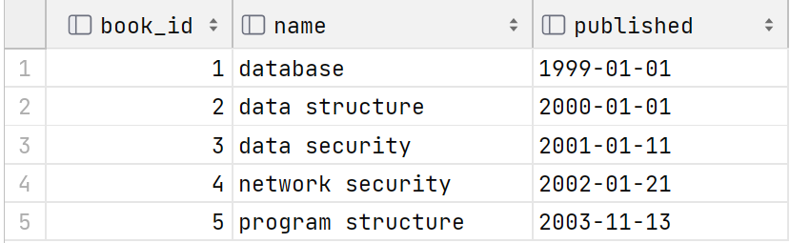

authors_of_books
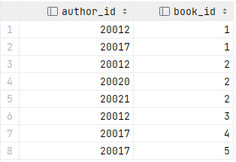

“CREATE TABLE” statements for these two tables:
DROP TABLE IF EXISTS books, authors_of_books;
CREATE TABLE books (book_id INT, name VARCHAR(20), published DATE);
CREATE TABLE authors_of_books (author_id INT, book_id INT);

Calculate the result generated by the following SELECT statements, note that the order of tuples does not matter in this task:
- SELECT author_id, name FROM books INNER JOIN authors_of_book ON (books.id = authors_of_book.book_id) WHERE published < '2000-01-01';
- SELECT author_id, name FROM books INNER JOIN authors_of_books using (book_id) WHERE books.name LIKE '%security%';
- SELECT author_id, book_id FROM books NATURAL JOIN authors_of_books WHERE author_id > 20020 AND books.name NOT LIKE 'd%';

Task 2: Outer Join
Given tables “student” and “enrolment” shown below:
student
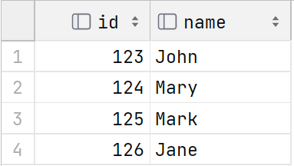
enrolment
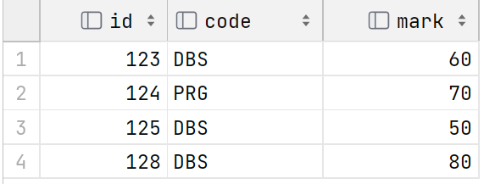
Calculate the result generated by the following SELECT statements, note that the order of tuples does not matter in this task:
- SELECT student.id, code FROM student left outer join enrolment on (student.id = enrolment.id) WHERE name LIKE '_ar_';
- SELECT enrolment.id, name FROM enrolment left outer join student ON (student.id = enrolment.id) WHERE name NOT LIKE '_ar_';
- SELECT * FROM student AS s1 LEFT OUTER JOIN (SELECT id + 1 AS id, name FROM student) AS s2 ON (s1.id = s2.id + 1);
- SELECT * FROM student s RIGHT OUTER JOIN enrolment e ON (s.id <> e.id) WHERE s.name NOT LIKE '%a%';

Task 3: Order By
Given table t below:
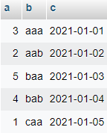
Calculate the result generated by the following SELECT statements, note that the order of tuples does not matter in this task:
- SELECT * FROM t ORDER BY a;
- SELECT * FROM t ORDER BY b ASC, a DESC;
- SELECT * FROM t ORDER BY a DESC, b ASC;
- SELECT * FROM t ORDER BY b, c DESC;

Task 4: Aggregate function, Group By & Having
Given table marks shown below:
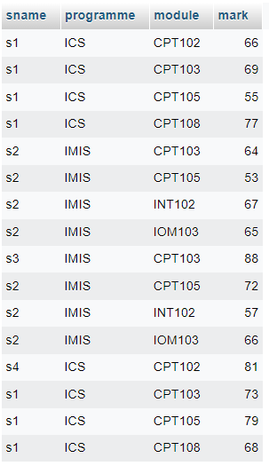
Calculate the result generated by the following SELECT statements, note that the order of tuples does not matter in this task:
- SELECT sname, avg(mark) AS average FROM marks WHERE programme = 'IMIS' GROUP BY sname HAVING average > 70;
- SELECT programme, avg(mark) AS average FROM marks GROUP BY programme;
- SELECT module, avg(mark) AS average FROM marks GROUP BY module;
- SELECT module, max(mark) - min(mark) AS average FROM marks GROUP BY module;
- SELECT programme,module, min(mark) AS average FROM marks GROUP BY programme,module;
- SELECT sname, module, mark FROM marks m1 WHERE mark >= (SELECT avg(mark) FROM marks m2 WHERE m1.module = m2.module GROUP BY module);

